Database Listing Installing

Download and Implement on server

Change domain url

Front-end

Back-end

Localization

Edit the menu bar(front stage)

Change Menubar logo

Edit the menu bar(back stage)

Admin account setting

Generate UUID

Import databases

News Setting

Steps

Facet setting

Steps

Identity Setting

Steps

Other settings(Robots, sitemap...)

Q & A

## 

## 

## Download and Implement on server

1. <https://github.com/tomcruihao/ServerConnect/tree/master/databaseList>
2. Put the folder in the directory where you want
3. Try: Open your browser and type “Your domain/directory path/index.php” and you will see the screen as below picture

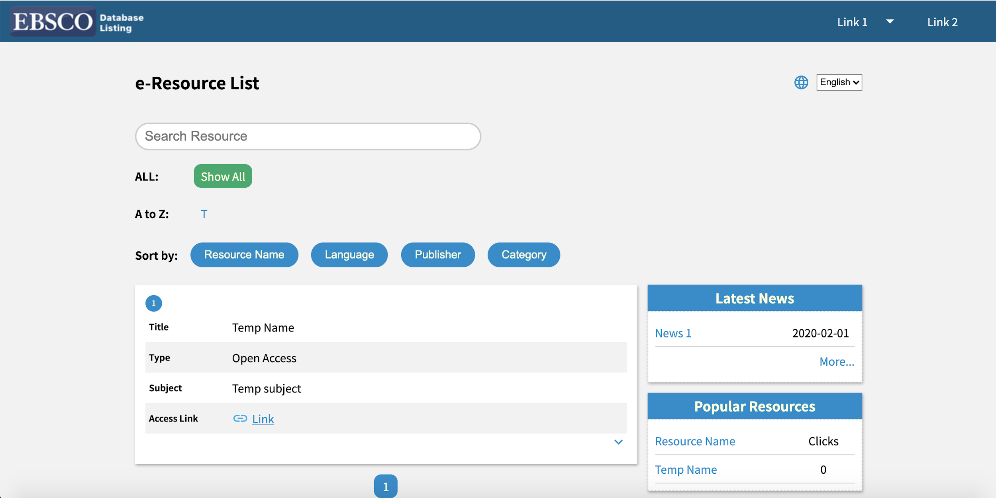

## 

## Change domain url

### Front-end

Open the file(Directory folder/lib/js/basicParameters.js)

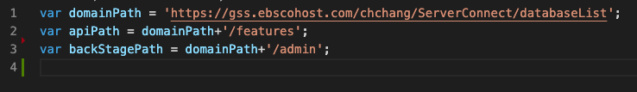

Change “domainPath” param to your “domain+directory”

e.g, ‘<https://192.168.1.1/the/directory/databaseList>’

### Back-end

This header has limited the connection to backend API and manage the timezone

file path: (Directory folder/features/_header.php)

header("Access-Control-Allow-Headers: *");

header("Access-Control-Allow-Credentials: true");

header("Access-Control-Allow-Origin: http://gss.ebscohost.com/");

header("Content-Security-Policy: upgrade-insecure-requests");

header('Content-Type: application/json;charset=UTF-8');

date_default_timezone_set('Asia/Taipei');

Change “Access-Control-Allow-Origin: **Your/Domain/Name**” to your domain name

Timezone: Please refer as below URL

<https://www.php.net/manual/en/timezones.php>

## Localization

Open the file(Directory folder/lang/lang.js)

The data structure as below:

const messages = {

en: {

message: {

parameters: …

}

},

local: {

message: {

parameters: …

}

}

}

If you want to localize your native language. Just change the parameters in local field.

## 

## Edit the menu bar(front stage)

Open the file(Directory folder/data/header_front.json)

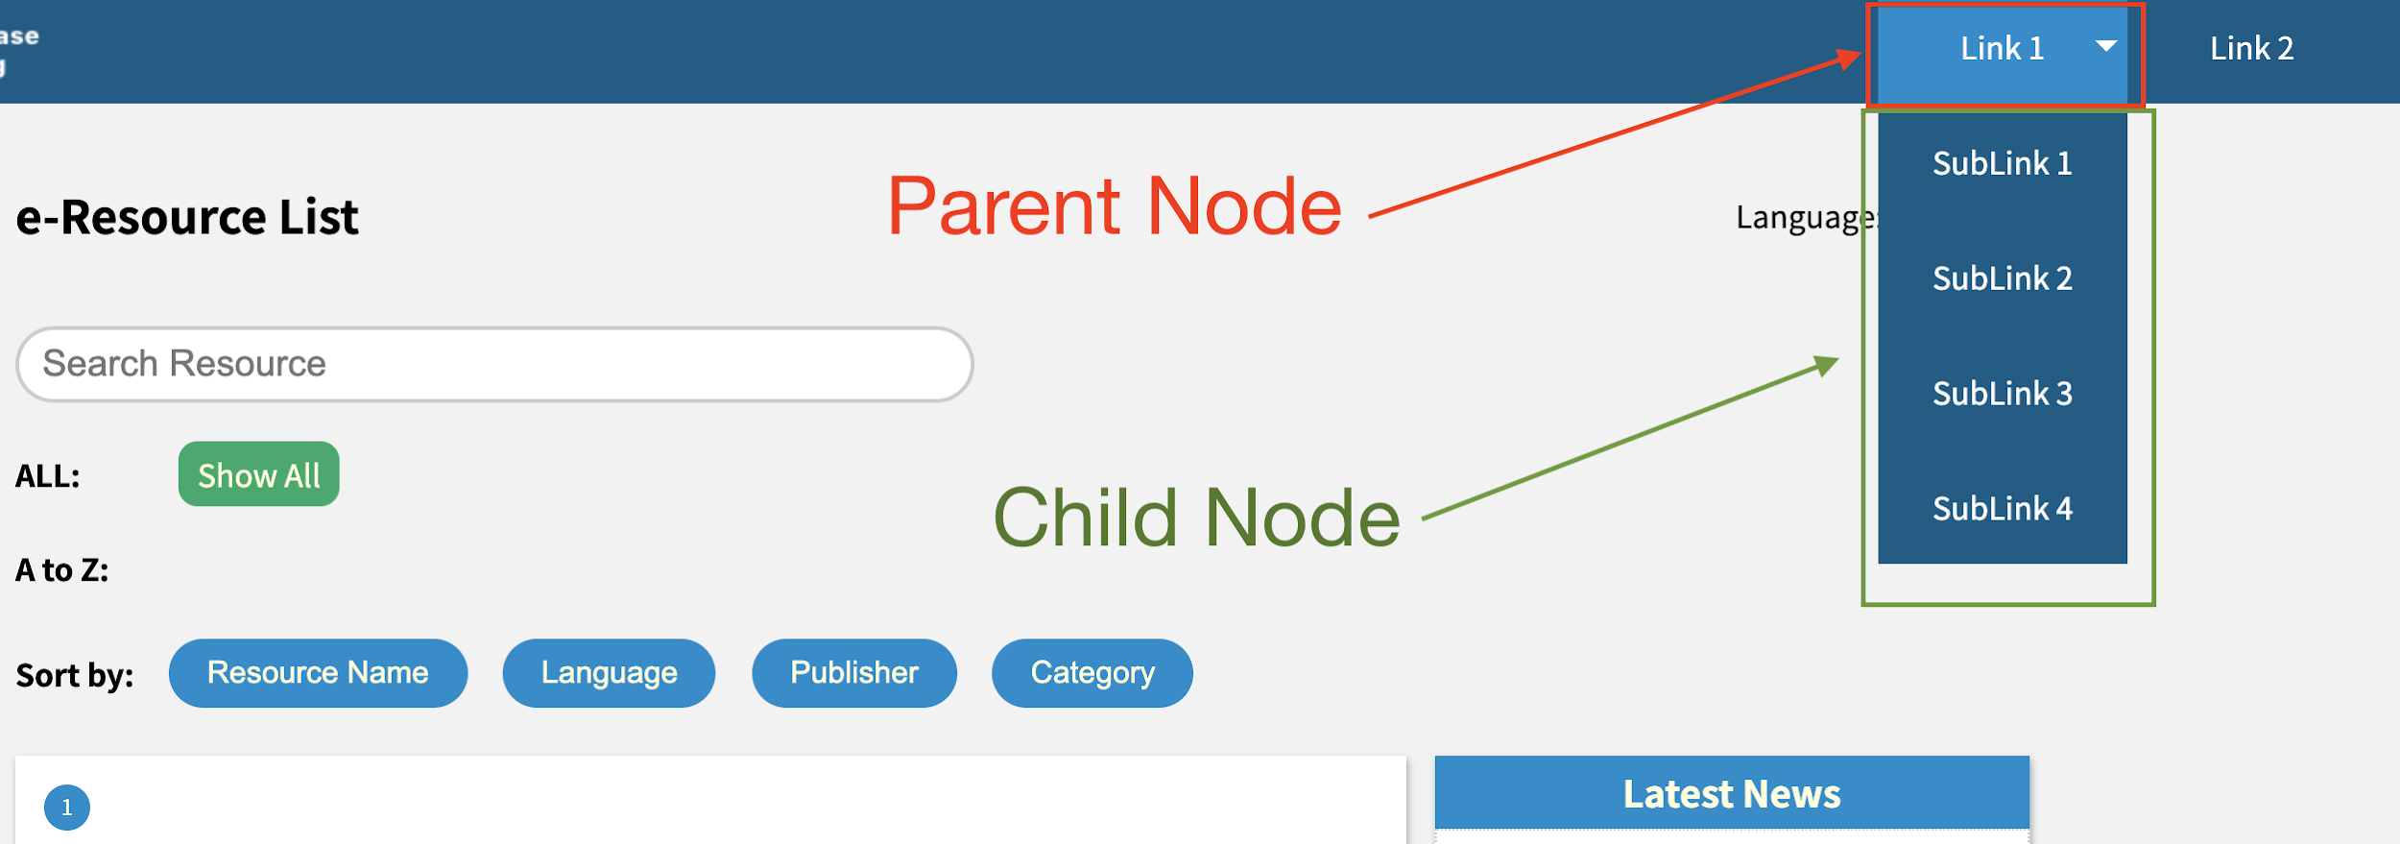

The JSON format as below

[

{

"title": {

"en": "english title",

"local": "Local title"

},

"link": "The external link",

"focus": false,

"child": [

{

"title": {

"en": "Child Title",

"local": "Local Child Title"

},

"link": "The external link",

"focus": false,

"child": []

}

}

]

## Change Menubar logo

file path(Directory folder/img/logo.png)

## Edit the menu bar(back stage)

Open the file(Directory folder/header/header_back.json)

The setting please follow the edit the menu bar(front stage)

## Language Setting

## 

## Admin account setting

Open the browser and go to “Your domain/directory**/privateTools/genP455w0rd.html**” and you will see the page as below

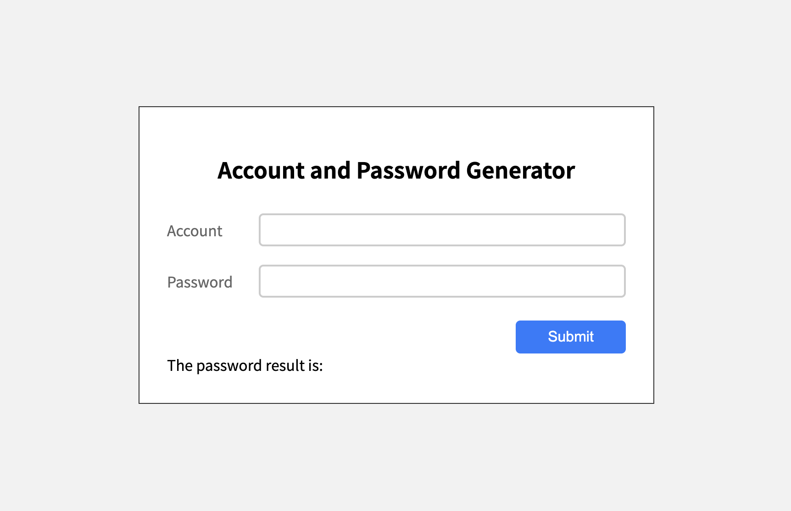

Type account and password in account and password field then submit. It will generate a password which has been encoded.

### Generate UUID

Go to <https://www.uuidgenerator.net/> and get a UUID

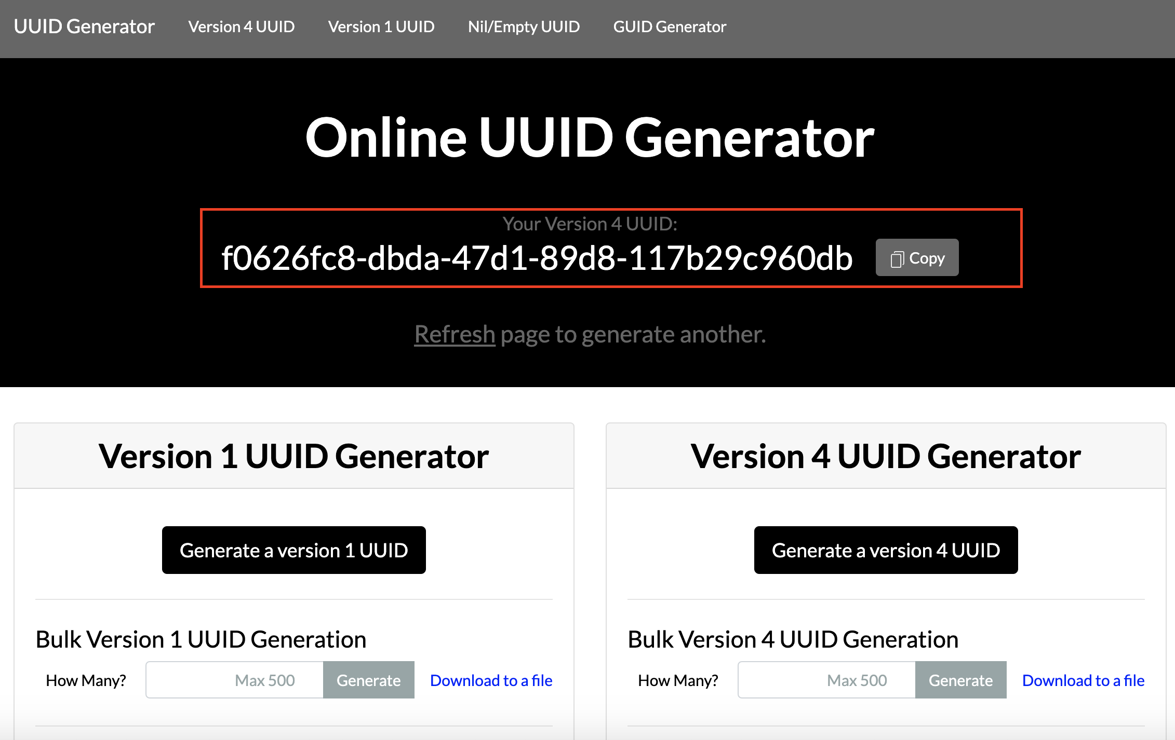

Open the file which path is “Database Listing directory/data/u5er.json” and will see a JSON format as below

[

{

"uuid":"The uuid",

"account":"The account",

"pwd":"The encoding password"

}

]

Paste uuid, account and encoding password in the u5er.json file then save

Go to “Your domain/directory**/admin**” to test

## 

## Import databases

Please download the template.txt (the file in this folder) and open it

Note: Please open it with Excel

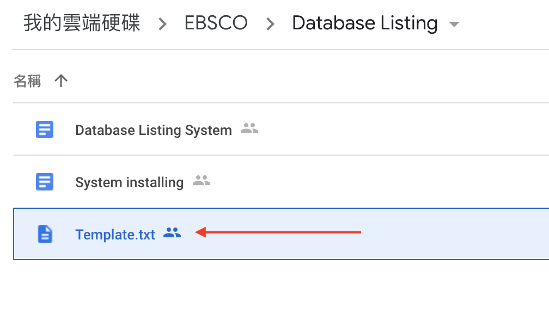

Then you will see as below picture

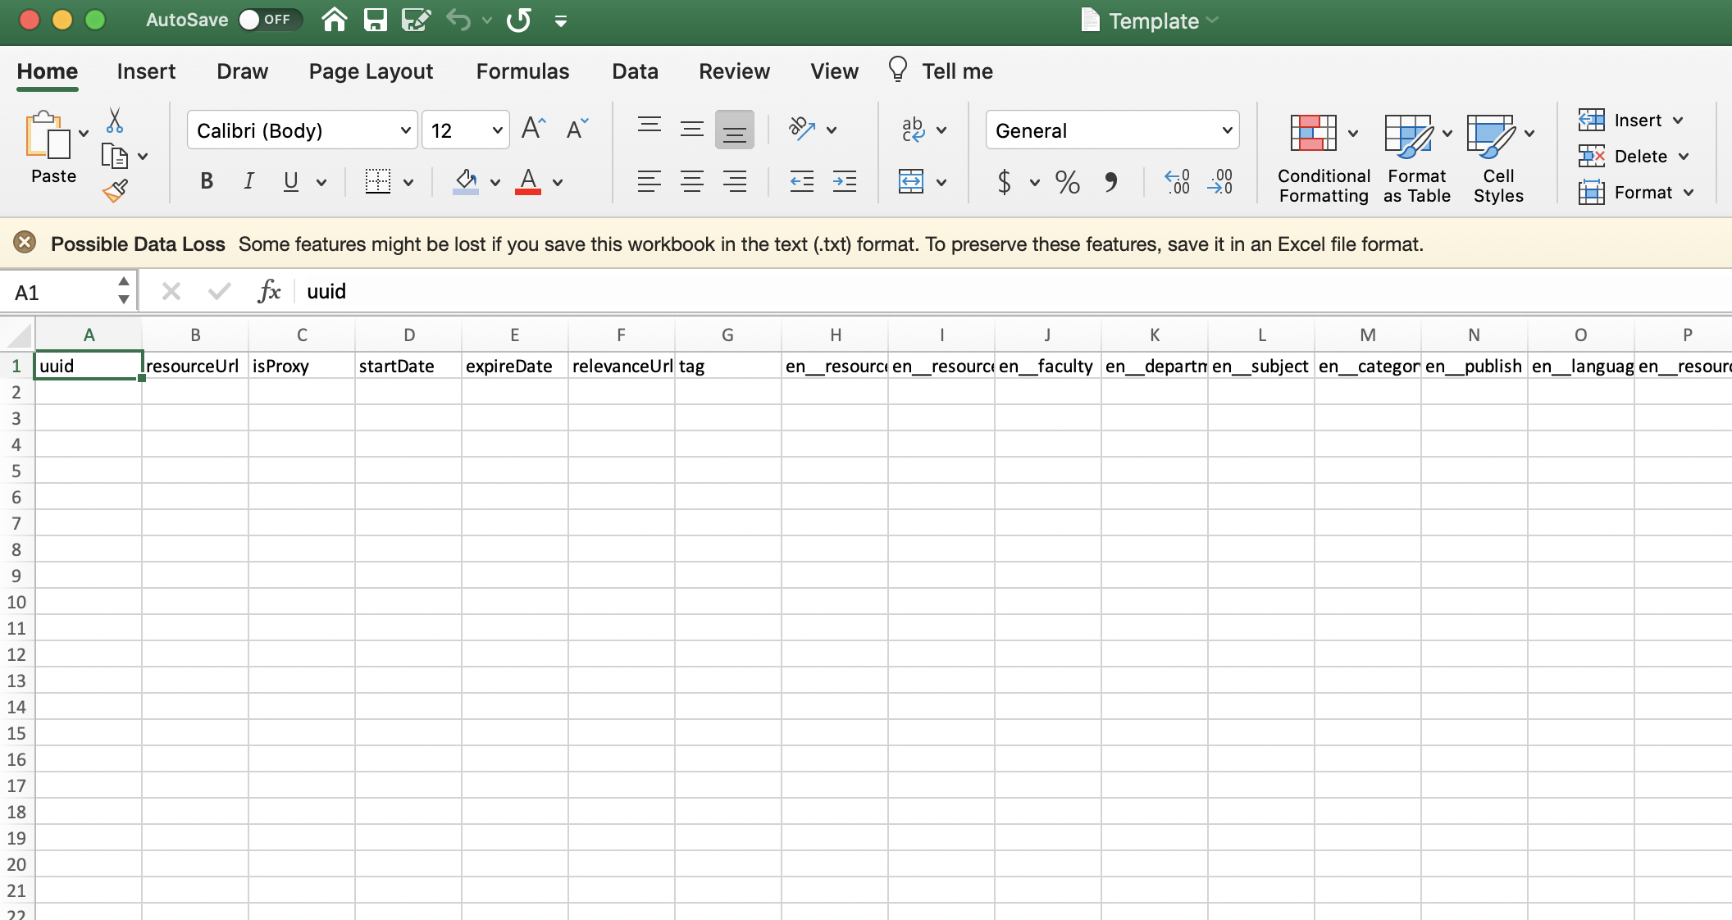

Please fill it or provide this document to a librarian to fill it

If finished the document, then go to the admin page

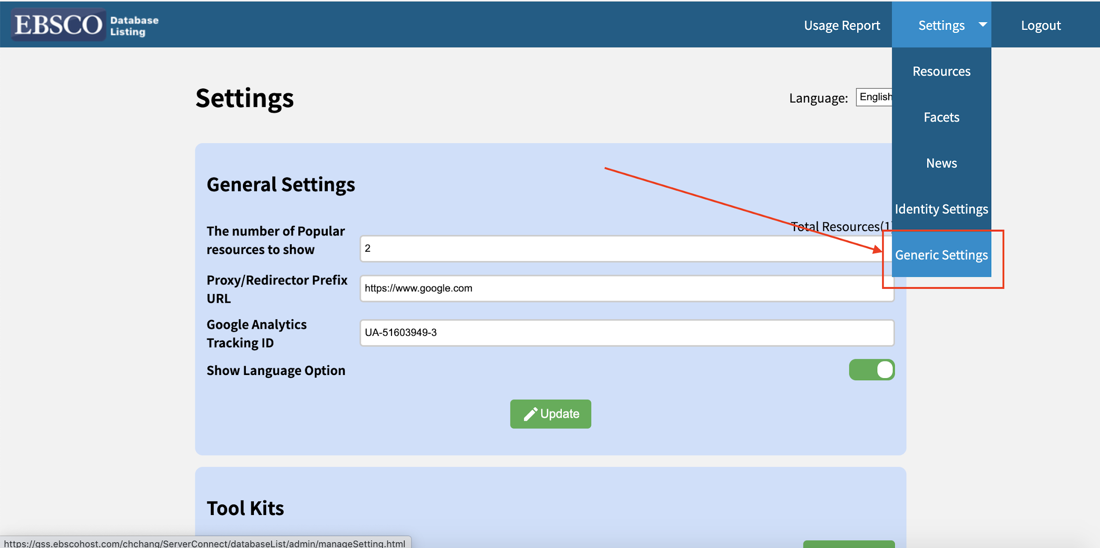

Upload the template.txt

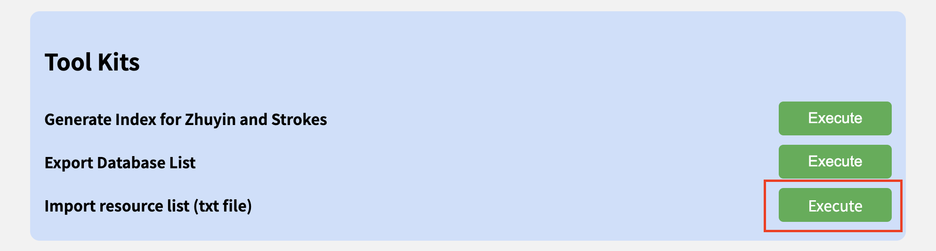

Generate Zhuyin and strokes(only provide tradition chinese)

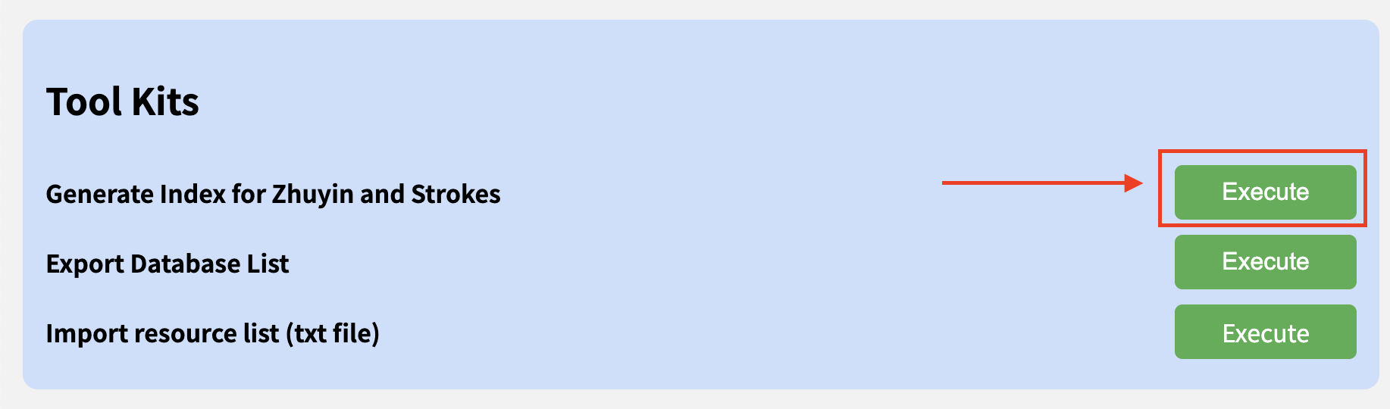

if watch the dialogue(as below picture) means successful

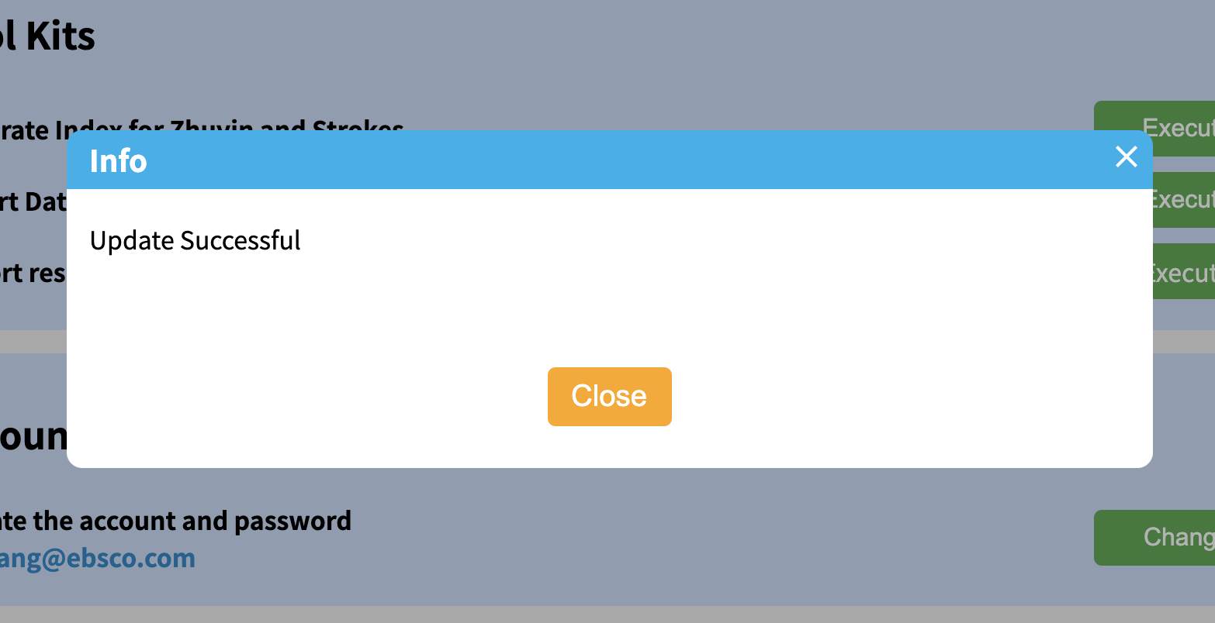

## News Setting

News settings can manage all news and provide the latest news for users. The news field in front-stage as below picture

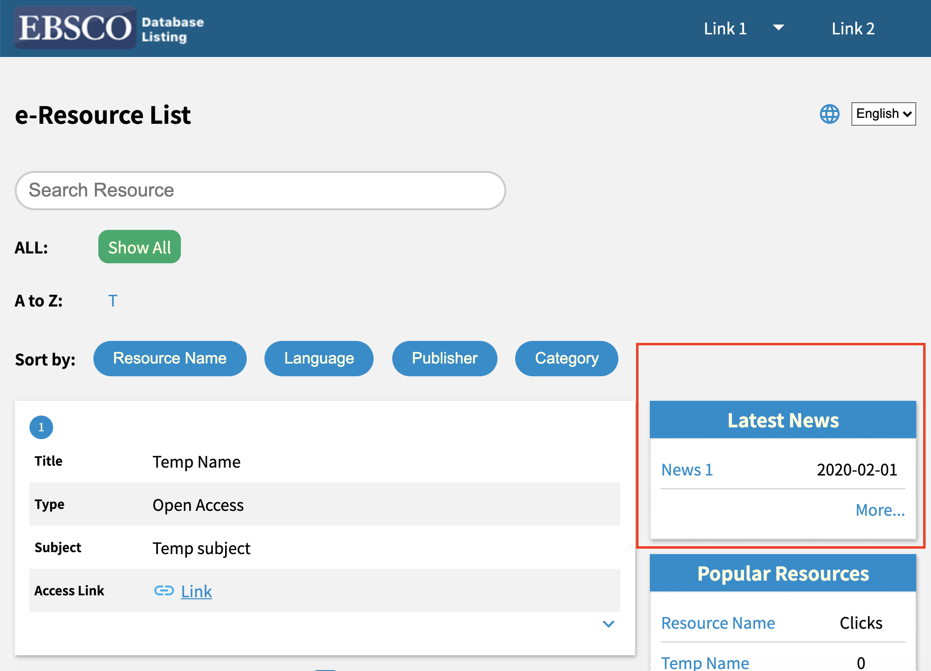

### Steps

1. Go to “your domain/directory/admin” and Login
2. Find “Setting” on the top right and click the “News” button(as below picture)

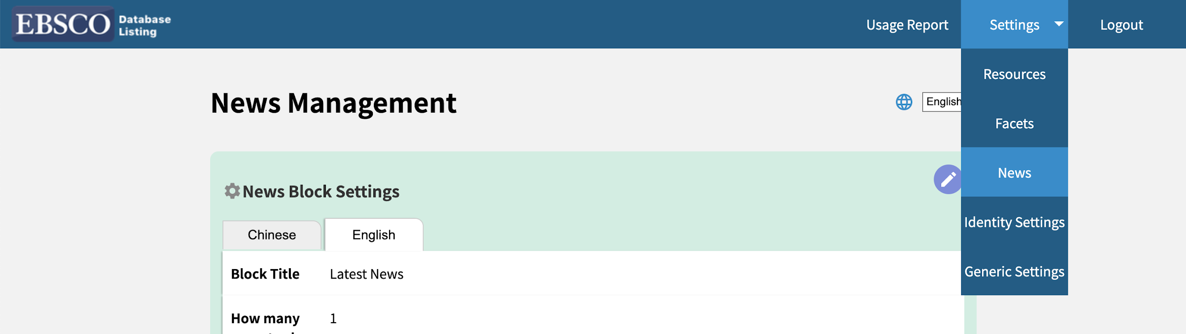

**New Block Settings:** This field set for the title of the latest news field, how many news shall display on the front-stage. If you need to edit the value, click the pen icon on the top right and it will popup a dialogue to edit the value.

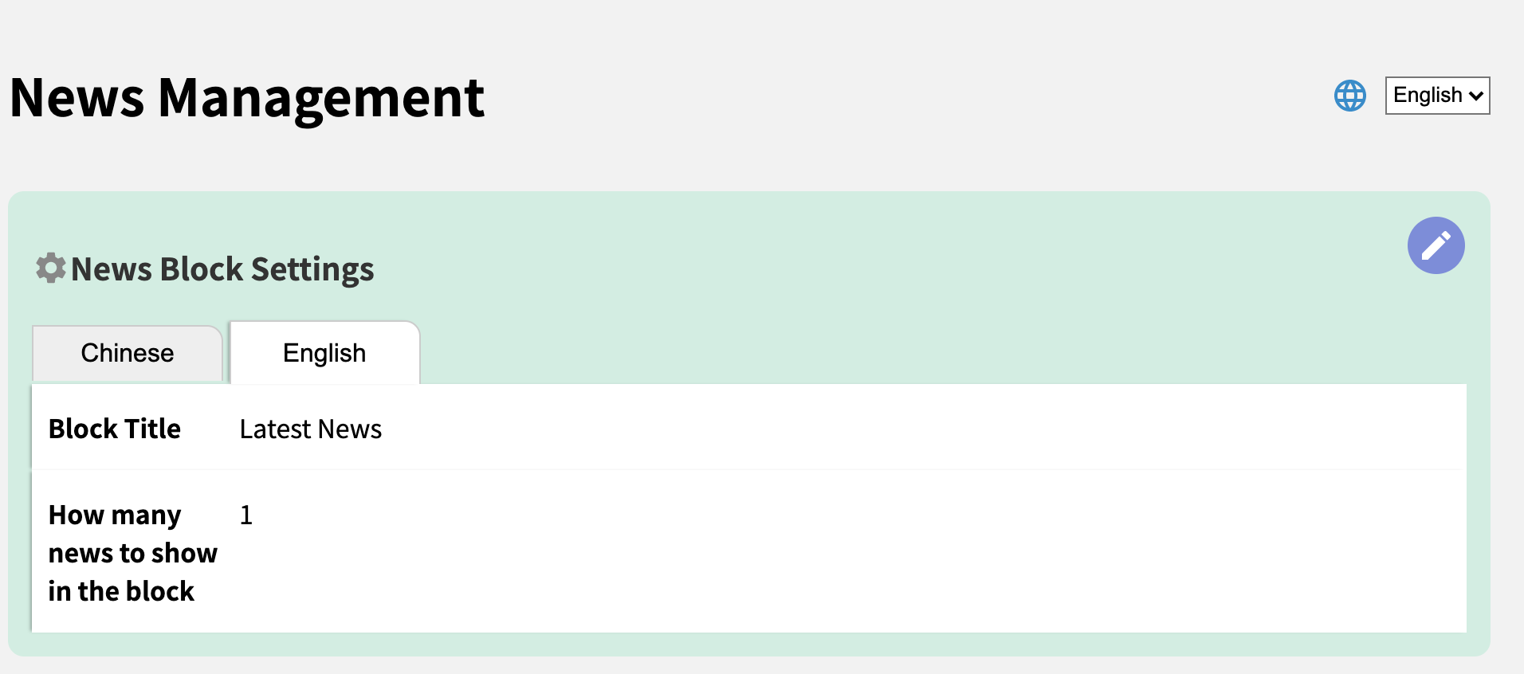

**Hot News:** This field set for the hot news when user visit the front-stage and it will popup the dialogue(as below picture).

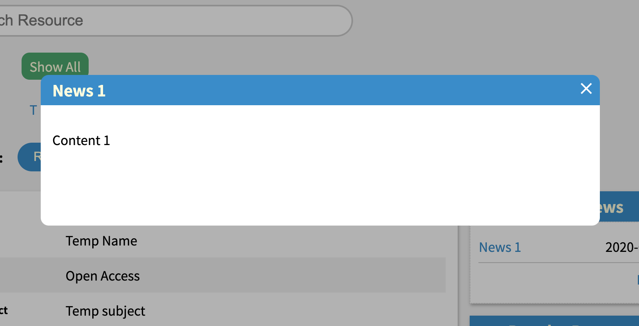

This field provides two features.

* The “Show” means enable/disable this feature
* The “Choose message” means to choose a news will show on front-stage

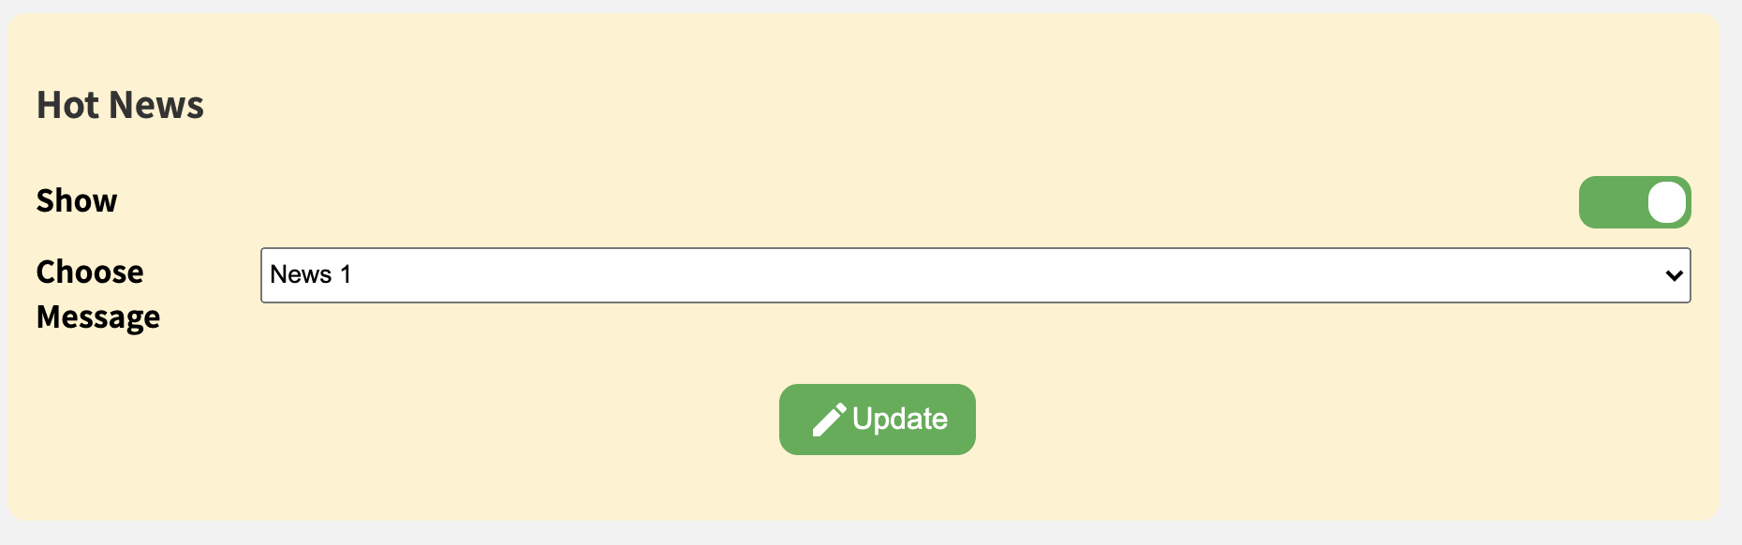

**News Field**: Provide news management include create/edit/delete features.

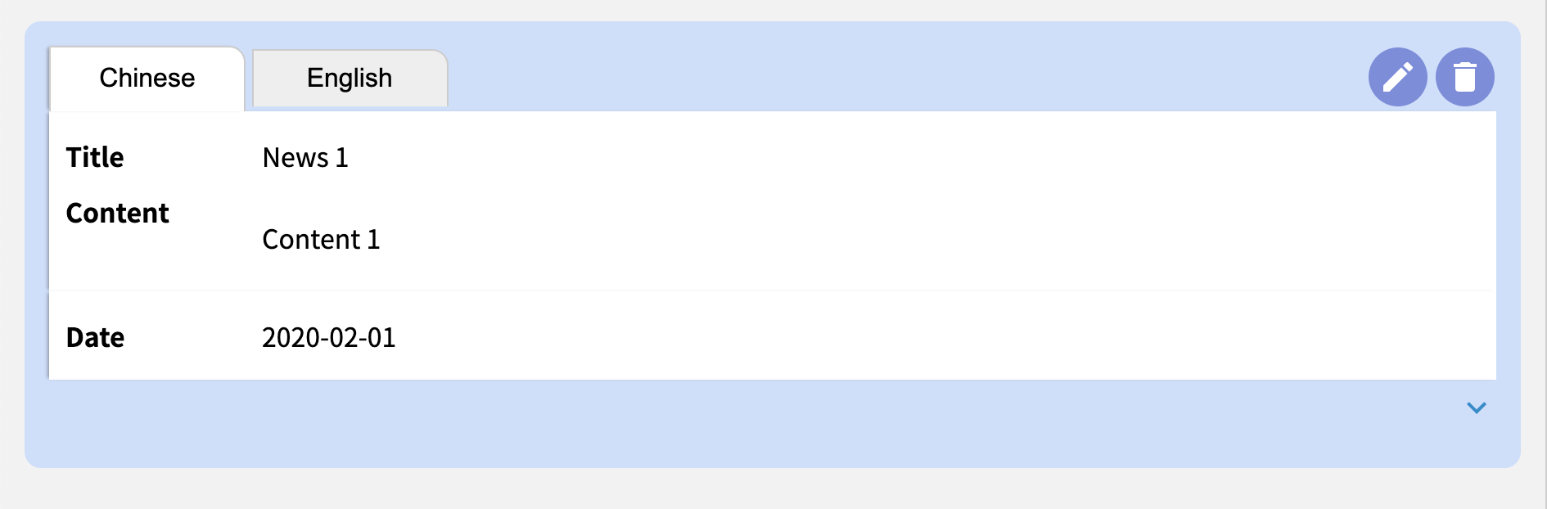

* **Create**: Find the icon with + sign fix on the bottom right of the screen and click it. Then it will popup a form to create a news
* **Edit**: Find the news you want to edit and find the pen icon on the top right of the news. Then click the icon and it will popup a form with the info of this news
* **Delete**: Find the news you want to delete and find the trashcan icon on the top right of the news.

## Facet setting

The facet setting manages all facets. The facet can filter the resource according to the various settings. The facet file will show under the popular resources field in the front-stage as below picture.

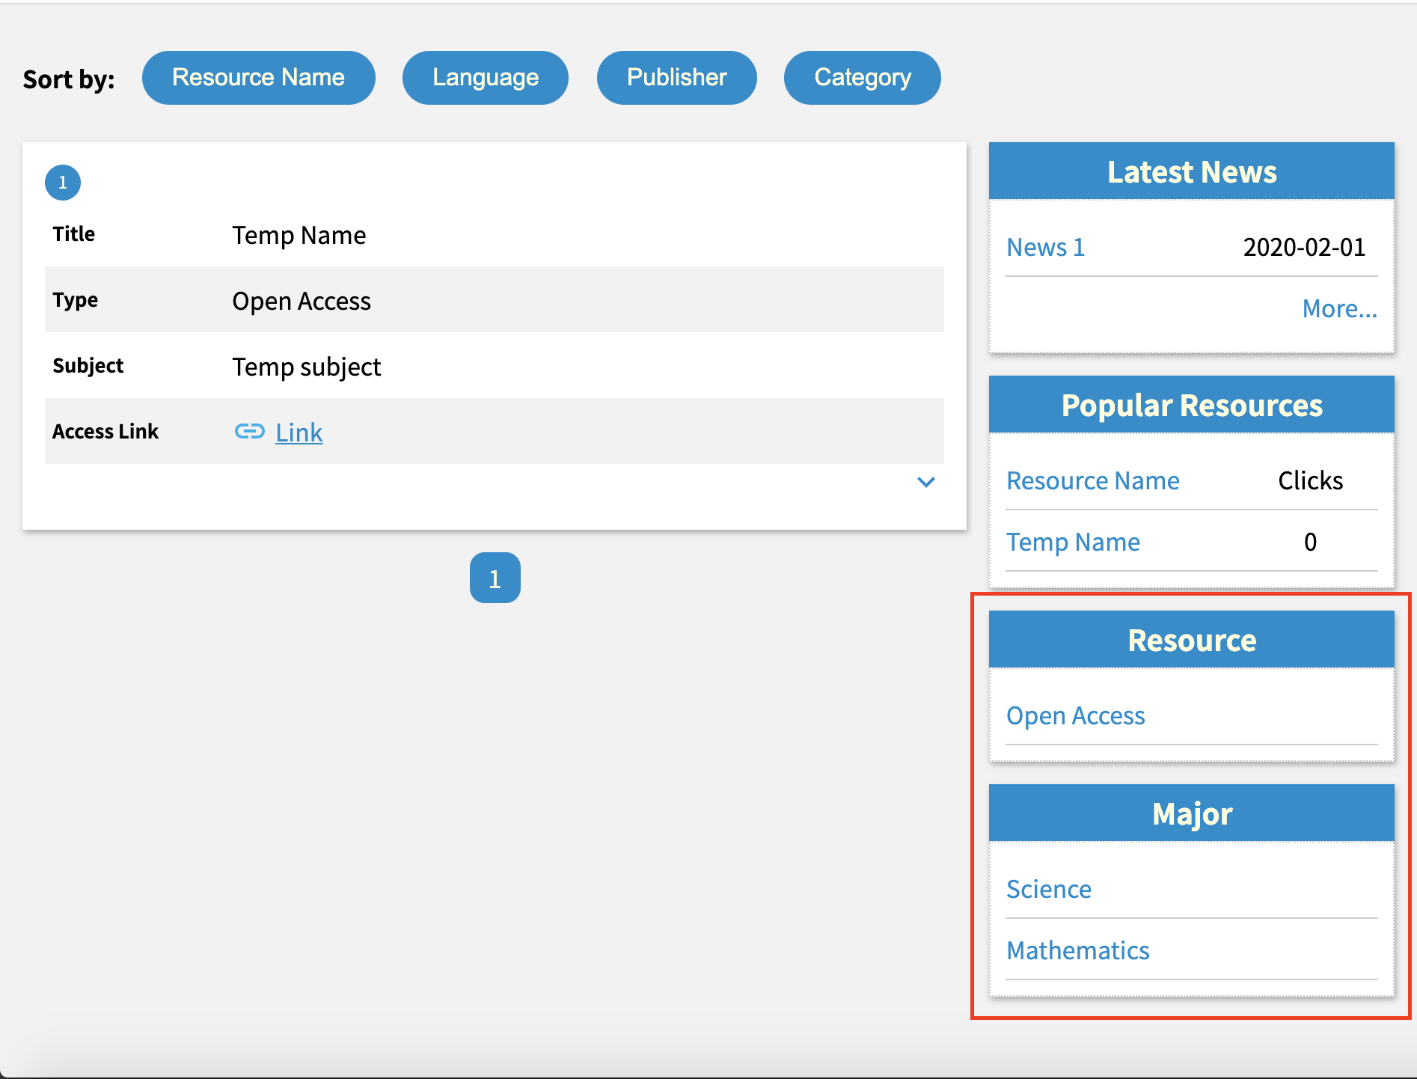

### Steps

1. Go to “your domain/directory/admin” and Login
2. Find “Setting” on the top right and click the “News” button(as below picture)

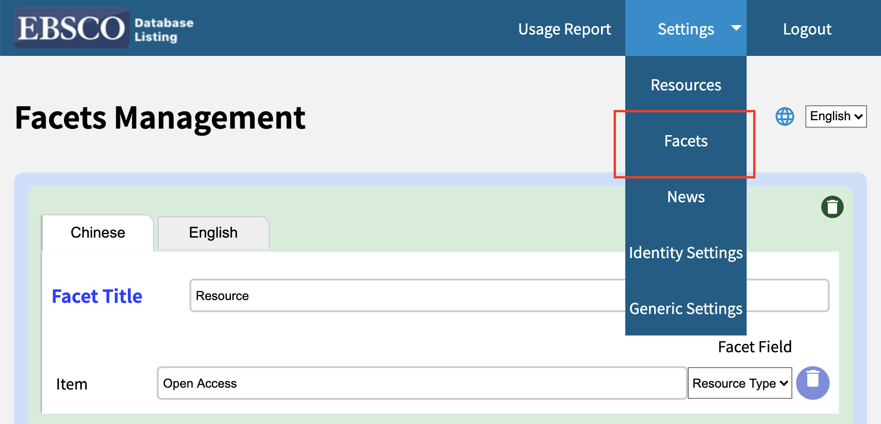

**Create a field of facet**

1. Click the +Add New Facet Block button and it will create a empty form on page
2. Fill the Facet Title
3. Fill the Item field, the facet field have some options like Subject,

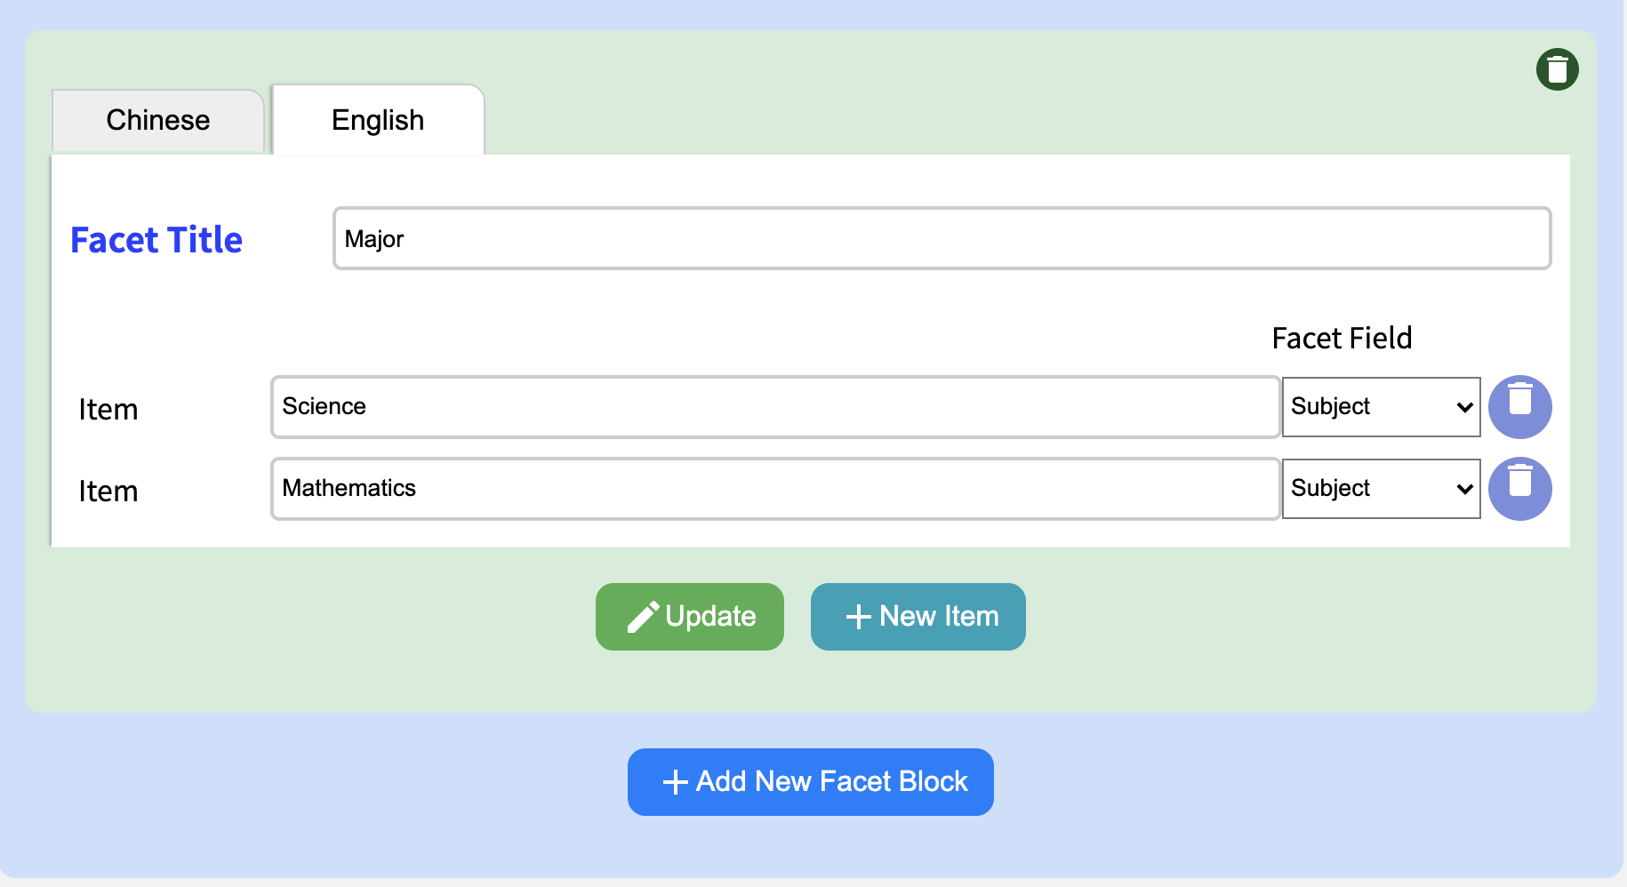

## 

## Commonly Resource Setting

The common resources can manage the common resources block on the front-stage.

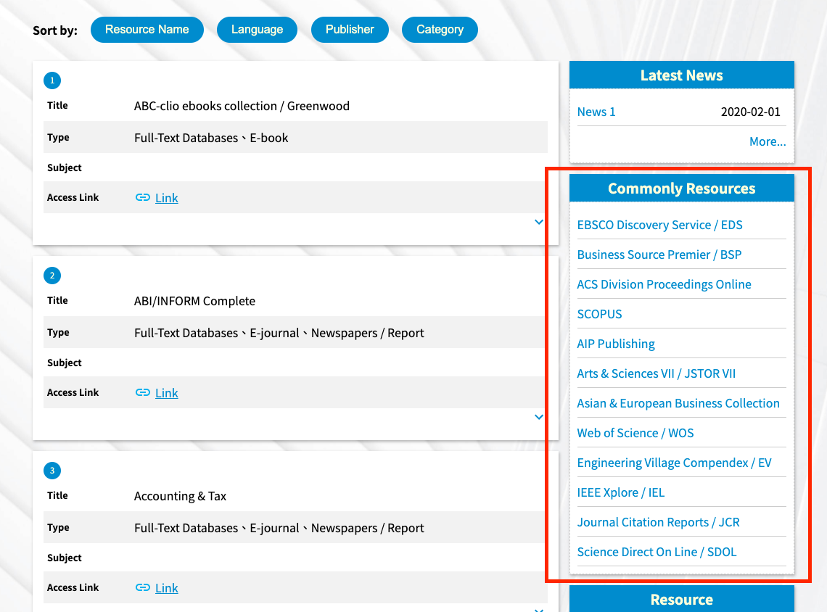

### Show/Hide the commonly resource block on front-stage

Steps

1. Go to “Database Listing directory/admin/manageCommonlyDatabase.html” or click the “commonly resource” on the top menu bar
2. Find the “Show on front stage” and there have a toggle button on the right of this topic(as below picture).



### Manage resource in management page

Steps

1. Go to “Database Listing directory/admin/manageCommonlyDatabase.html” or click the “commonly resource” on the top menu bar
2. You will see two areas, one is Commonly Resource List and the other one is All Resources(As below picture). The Commonly Resource List means the resource list in the Commonly Resource block on the front-stage. The All Resources means the whole resources you have and those resources have not been selected.

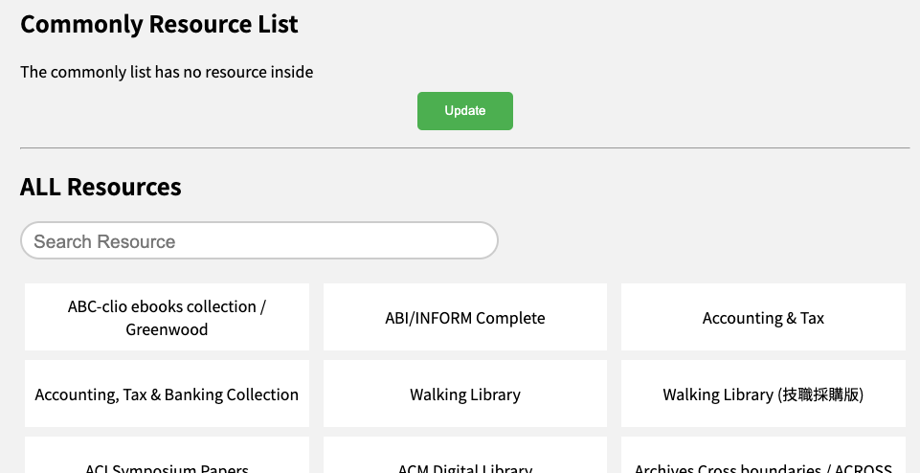

1. Find a resource you want to put into the Commonly Resource List and mouse hover to that resource then clicked. The resource will move to the Commonly Resource List area.

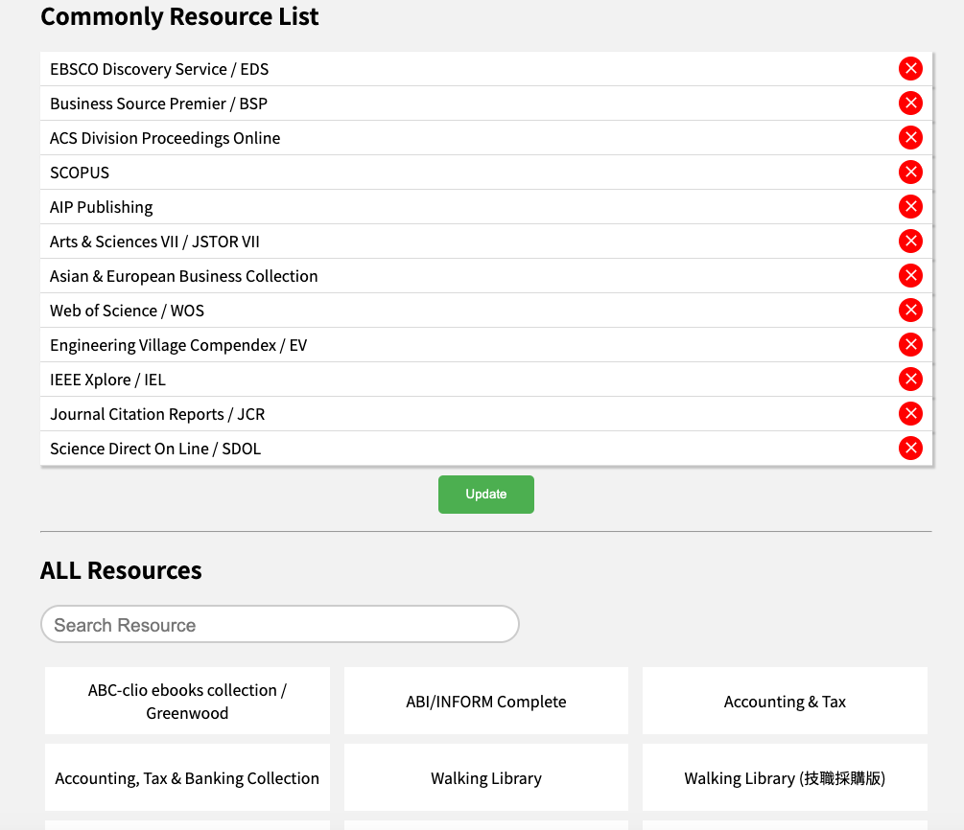

1. If you want to order those resources in the Commonly Resource List, just move your mouse to the resource you want to adjust and use drag and drop to change the position.

## 

## Generic Setting

This page is set for generic settings. You can set how many resources on a page or Google Analytics Tracking ID...etc.

### General Settings

**The number of resources to show:** Show how many resources of a page

**The number of Popular resources to show:** Show the number of popular resources

**Proxy/Redirector Prefix URL:** Set proxy url

**Google Analytics Tracking ID:** Put the GA serial number

**Show Language Option:** Control the localization options on the front-stage

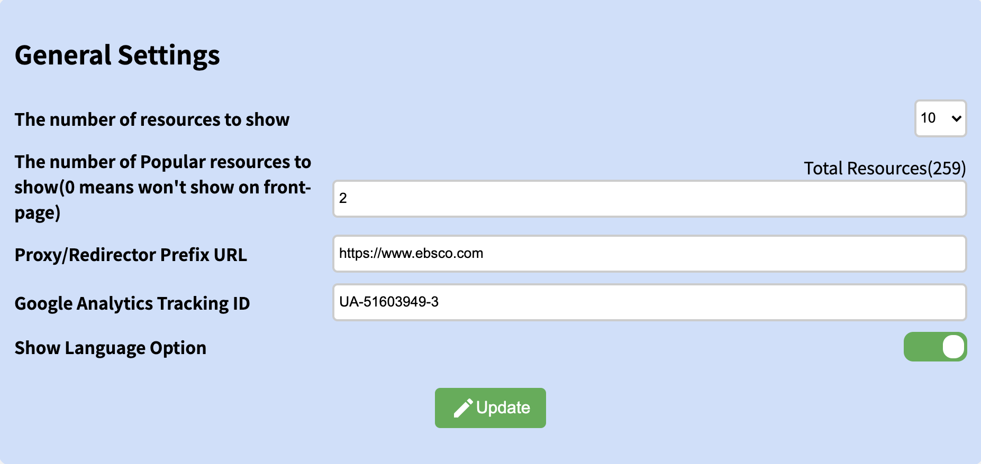

## 

## Expiring Checking

The expiring checking can help to notify the administrator to note the expiry status of resources.

### Steps

1. Go to “your domain/directory/admin” and Login
2. Find “Expiry Resource” on the top right and click

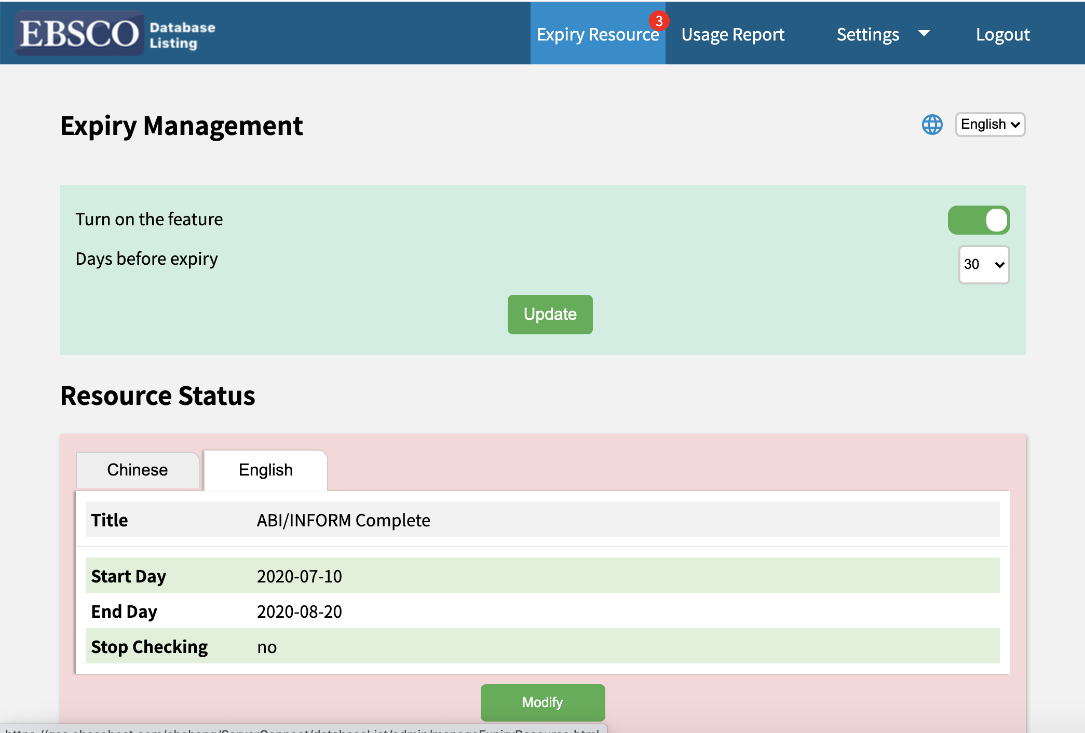

### Expiry Setting:

**Turn on the feature**: Enable/Disable the notification. If disabled, the number will not show on the top right of the expiry resource tag

**Days before expiry**: Set the days before the resource expiry. Options include 7, 14, 30, 60, 90

## Identity Setting

The identity setting can record which role visit which database.

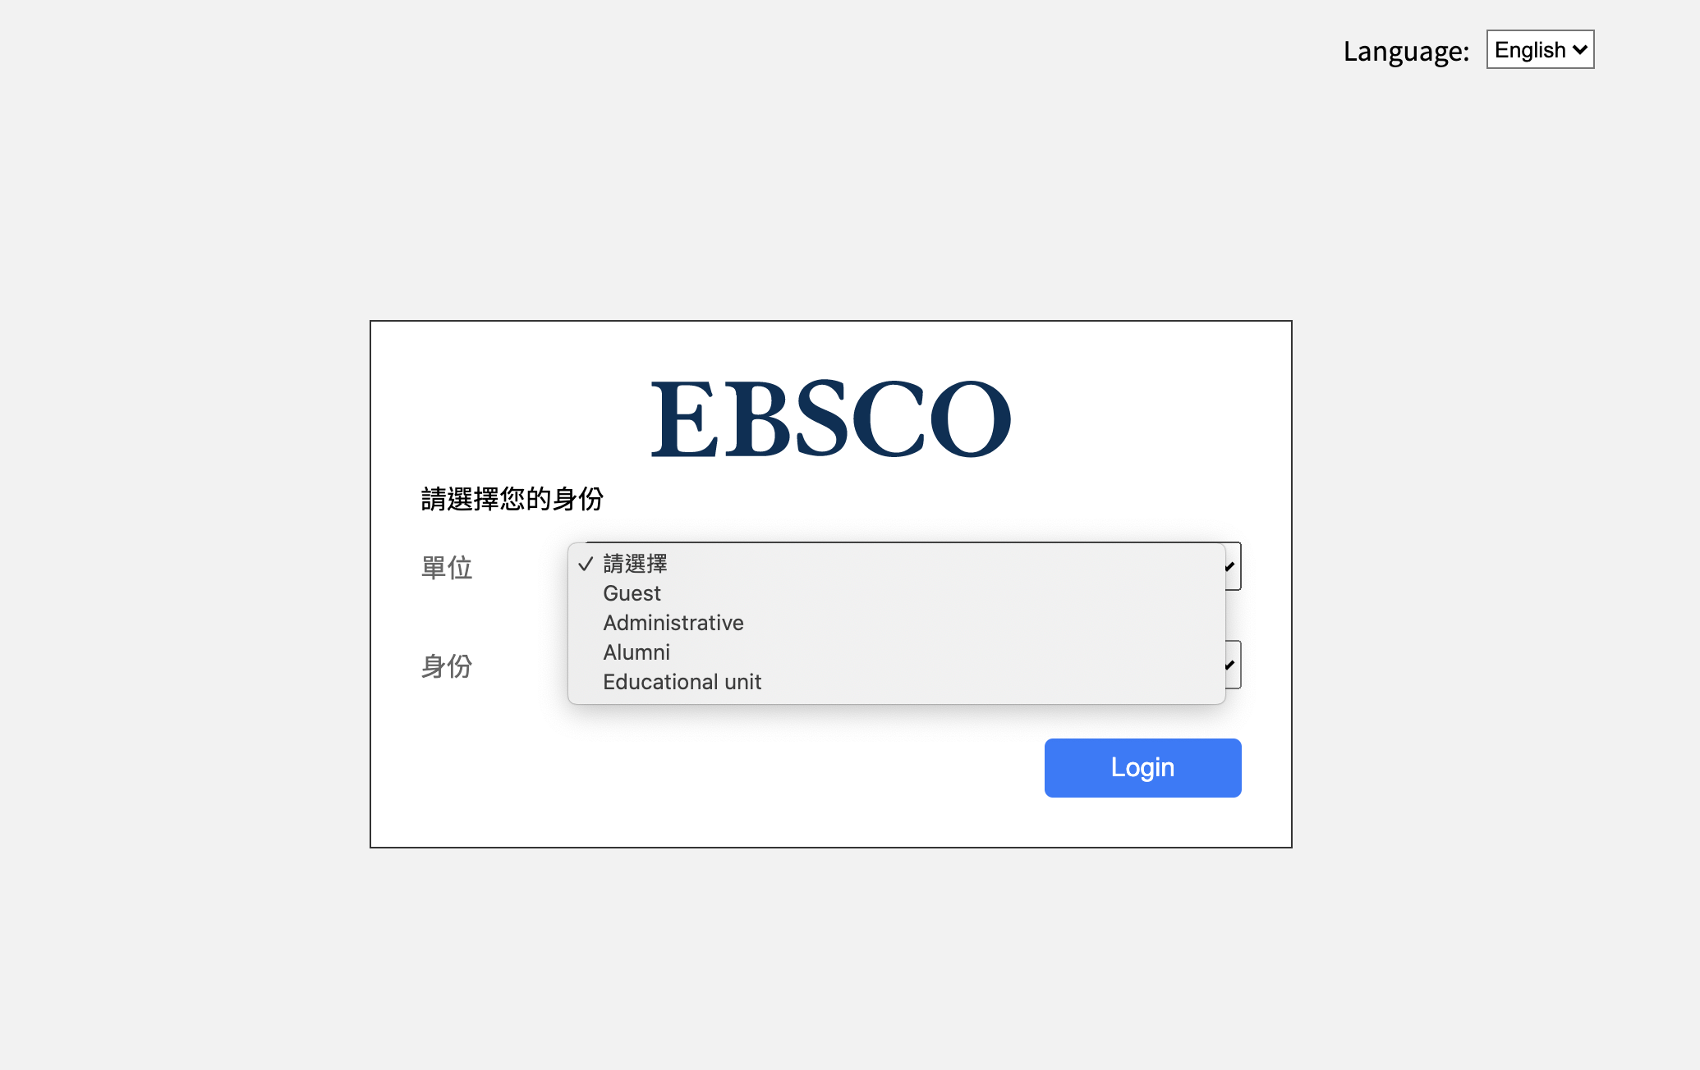

Note 1: Please do not modify it from JSON file directly unless you know the structure unless you understand how to operate the “identity of click report”, management identity...etc

Note 2: The Identity Setting do not support localisation now

### Steps

1. Go to “your domain/directory/admin” and Login
2. Find “Setting” on the top right and click the “Identity Settings” button(as below picture)

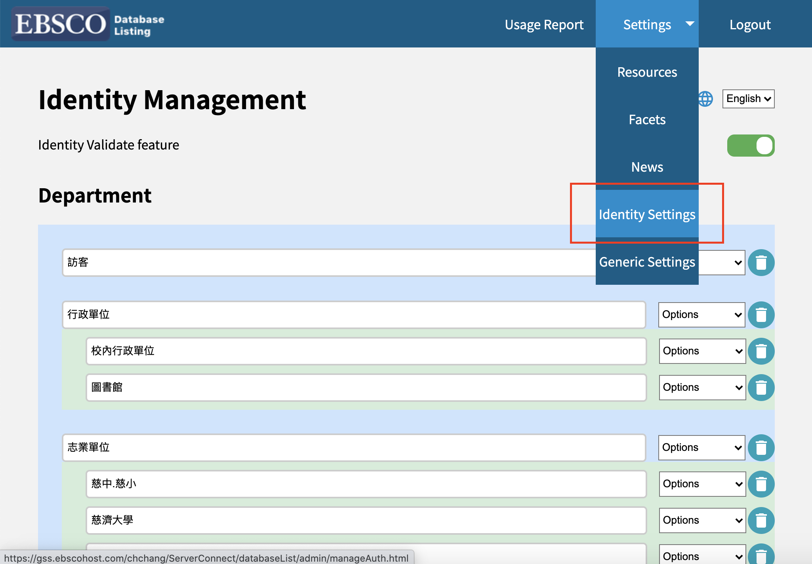

* **Identity validate feature:** Switch the button, the white ball in left means turn off and in right mean turn on. If this feature turns on when the user clicks a link from a database and it will redirect the user to check the user identity

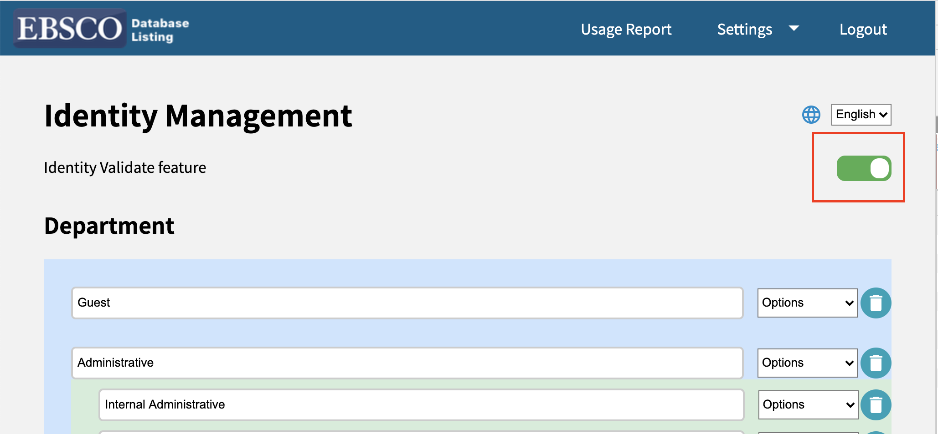

* **Department:** To set departments info. The text field is to set the department name. The right hand side has a selector. the selector has two options same level and next level. The same level means to create a new text field and the level is the same as the level you selected. The next level means to create a child level for this department

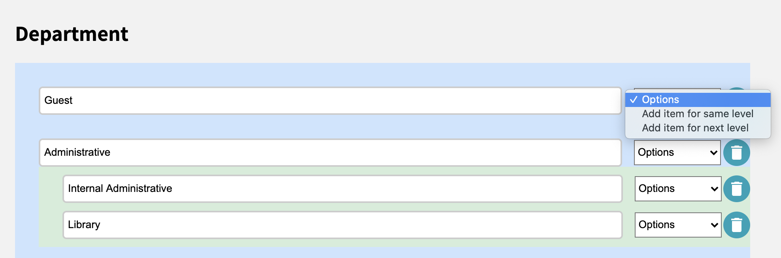

* **Identity:** To set identity info. Same as department but only provide one level

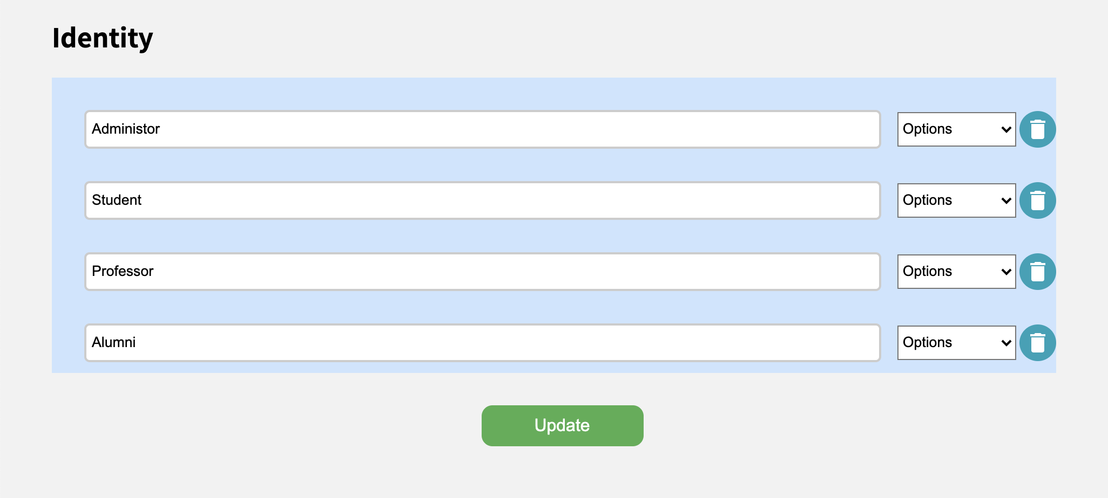

## Other settings(Robots, sitemap...)

**Robots**: Find the file “robots.txt” in the directory. Just follow the formate to set the path you don’t want the robot to crawl

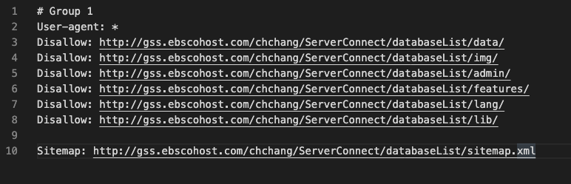

**Sitemap**: Find the file “sitemap.xml” in the directory

You can use some platform to generate the site map  
<https://www.xml-sitemaps.com/>

## Q & A

Why features can not work?

1. Please check the protocol, it have to use https.

2. Please check the data folder. Give the writing privilege for those file under the data folder.

3. Check browser. Due to this system write by Vue.js that doesn’t support the **IE** browser